Claude Prompt:
Help me create and understand the Create Account Process Server Side currently dont have the create account UI but I have provided both java and python projects. I think my server would be similar to the login server but i don’t understand it really
Response:
Let me read the relevant files to understand the existing patterns before explaining.Now let me create the visual explanation and the new files.Here's how the whole system works, then I'll show you exactly what to build.
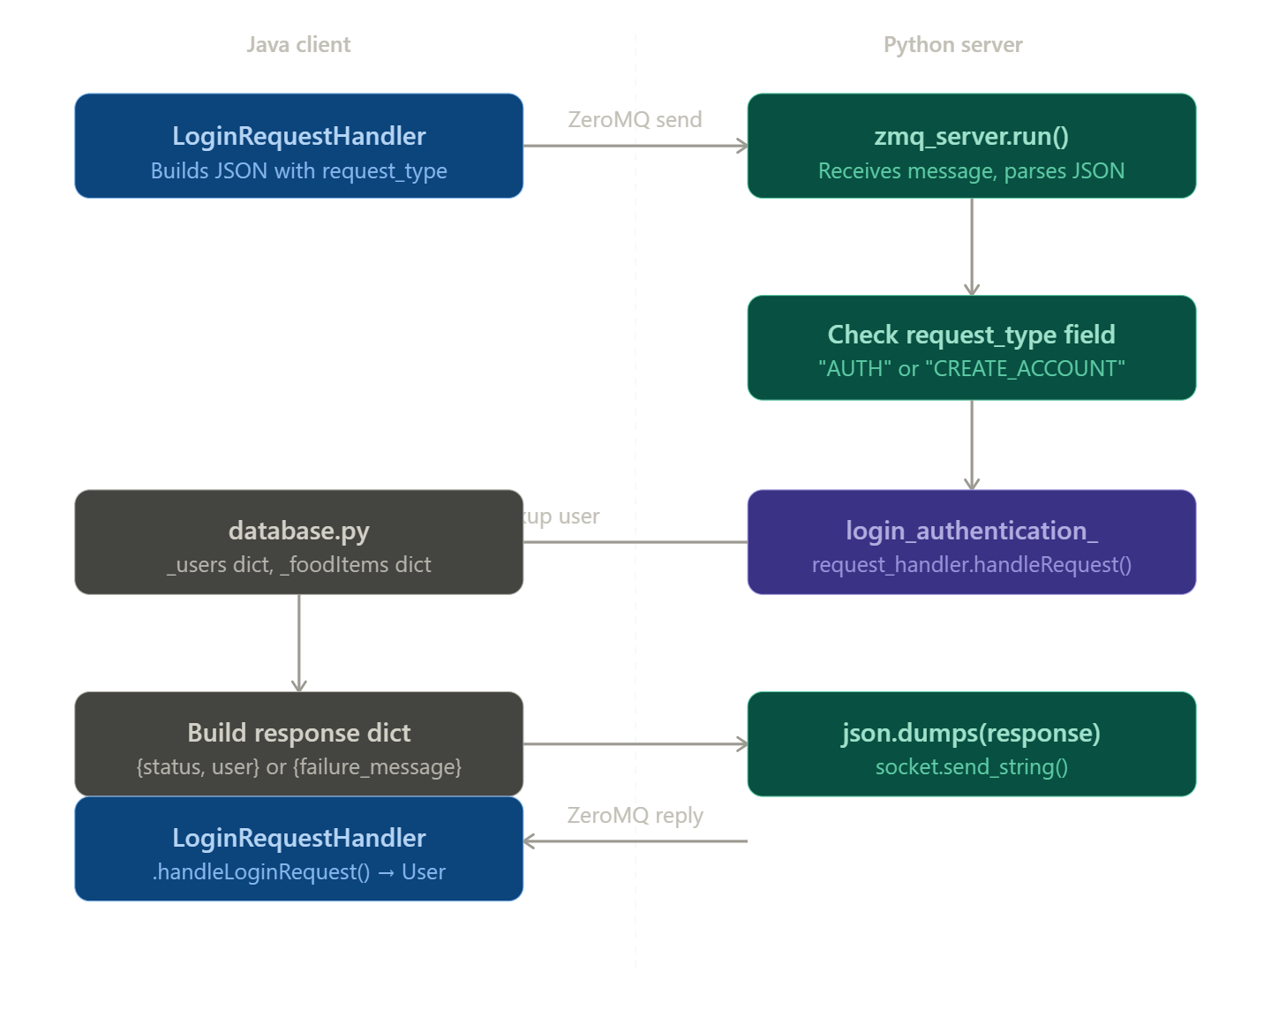
The architecture is a simple request → route → handle → respond loop. The Java client sends a JSON string over ZeroMQ, the Python server receives it, checks the request_type field to decide which handler to call, and sends a JSON response back.
For login, the flow looks like this:Now here's what you need to create. Create account is almost identical to login — you just add a new constant, a new handler file, and a new elif branch in the server. Let me build all three files:Here's what each piece does and how it all connects:
constants.py changes — two lines added: KEY_NAME = "name" (the new field the Java client will send) and CREATE_ACCOUNT_REQUEST_TYPE = "CREATE_ACCOUNT" (the routing key). Every handler and the server use these constants so you never hardcode strings.
create_account_request_handler.py — mirrors the login handler exactly, but instead of looking up a user it creates one. The steps are: validate the fields exist → check the username isn't already taken → build a default DietGoals and empty FoodLog → construct a User → write it into database.getUsers() → return the new user dict on success or a failure message on error.
zmq_server.py changes — one import and one new elif block. The server's while True loop is just a big router: it parses the JSON, reads request_type, and hands the whole dict off to the right handler. You're just adding another branch to that elif chain. Nothing else changes.
On the Java side, when you build the UI you'll need a CreateAccountRequestHandler.java that works just like LoginRequestHandler.java — it builds a JSON map with request_type: "CREATE_ACCOUNT", username, password, and name, sends it via ServerClient.send(), and parses the response back into a User object.
One thing to be aware of: database.getUsers() currently returns the live _users dict, so writing to it (database.getUsers()[username] = ...) works but the data is only in memory — it resets when the server restarts. You'll want to add a database.addUser() function that properly inserts into _users the same way loadDefaultData() does, but the current approach works for testing.

